Module 1 — Understanding MSP
Getting a fair price for farm produce is a farmer’s right — and the journey to understanding that right begins with understanding the Minimum Support Price (MSP).

1. Learning Objectives
- Understand what the Minimum Support Price (MSP) is, for whom it is fixed and why.
- Understand the complete process of fixing MSP and the meaning of the components behind it — A2, FL and C2.
- Clearly understand why the production cost of your crop should be recorded accurately and regularly.

2. Introduction
One root cause of the difficult economic condition of Indian farming is often overlooked: farmers do not keep a proper record of the financial dealings of their farming — that is, the actual production cost, the output obtained, and the profit or loss on each crop. Not keeping this record is no small matter; this is where almost every economic difficulty of farmers begins.
The biggest reason for a loss or low profit in a crop is that farmers do not get a fair market price for their produce. This happens mainly because the Minimum Support Price (MSP) fixed by the government is much lower than the actual need. To understand this, we first need to understand how MSP is determined.

1.1 Why does farm produce not get a fair price?
The biggest challenge facing farmers is that their produce does not get the expected market price. But what lies at the root of this problem? Not keeping an accurate account of the cost of production of farming.
If the actual cost of your crop is not known, it is not possible to say firmly what the fair price should be. And the most effective tool in a farmer’s hands for demanding a fair price is — an accurate account of his farming costs.
MSP means Minimum Support Price — the government fixes this minimum price for some major crops, and the cost of production of farming is considered while fixing it. That is why, if the production cost figure is low, the MSP based on it can also remain low.

Figure 1.1 — The real problem of farm produce not getting the expected market price

1.2 For which crops, and how, is MSP fixed?
The government currently fixes MSP for 22 crops. These include the following groups:
- Cereals (7 crops): rice, wheat, jowar, bajra, maize, ragi, barley
- Pulses (5 crops): moong, urad, tur, gram, masoor
- Oilseeds (7 crops): groundnut, mustard and rapeseed, niger seed, soybean, sunflower, sesame, safflower
- Fibre and other crops (2 crops): cotton, jute
- Horticultural / commercial crops (4 crops): sugarcane, onion, potato, coconut
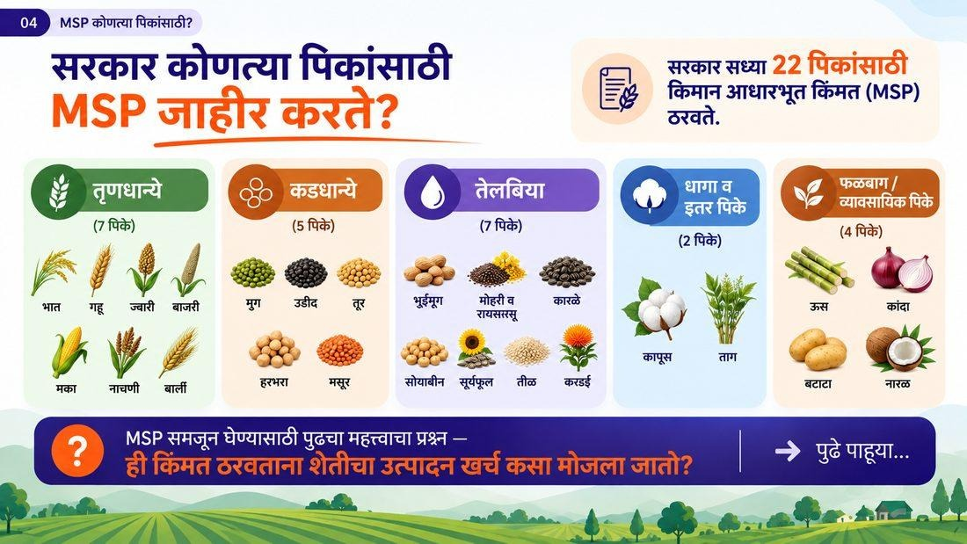
Figure 1.2 — The 22 crops for which the government currently announces MSP
MSP is not an arbitrary figure — it goes through a defined process: farm-level cost data → analysis by the Commission for Agricultural Costs and Prices (CACP) → CACP price policy report → consultation with the government → consideration by the Cabinet → announcement of MSP.
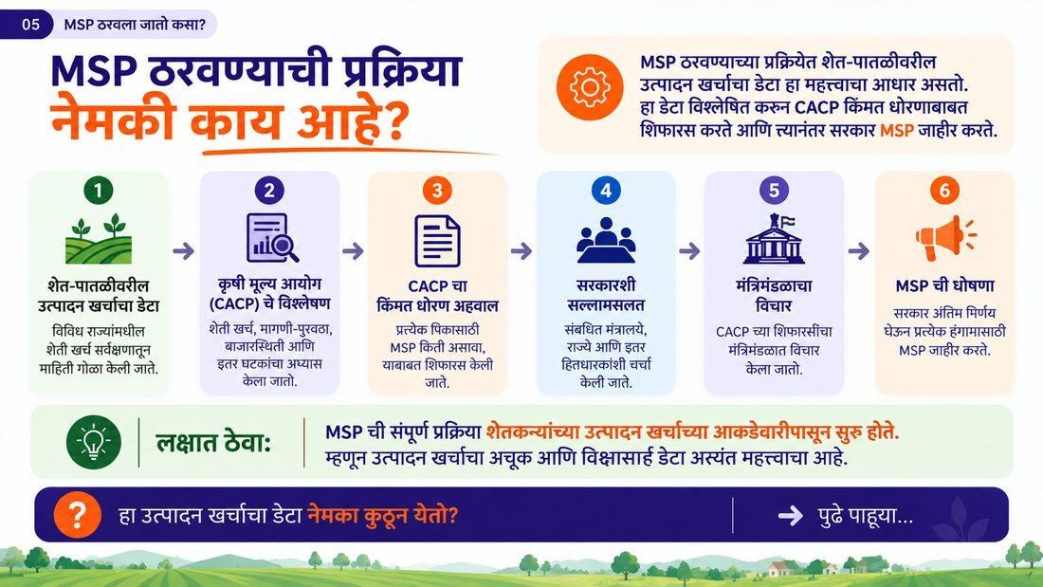
Figure 1.3 — The six-step process of fixing MSP
Put simply, MSP is fixed at one and a half times the cost of farming (A2+FL). This means the MSP a farmer finally gets depends entirely on how accurately A2+FL has been worked out. If this starting figure itself is low, the MSP based on it will also remain low — however correctly the formula is applied.
General formula for MSP
MSP = 1.5 × (A2 + FL)
That is, understanding the accurate account of A2 + FL is extremely important.

1.3 Understanding A2, FL and C2
The A2+FL figure is not a guess — it is worked out from data collected from actual farms in 21 states through state agricultural universities. To work out the production cost of each crop, about 10,440 sample farms are studied.
A2 — Actually paid-out cost: This includes the cash and in-kind expenses a farmer incurs directly from his own pocket for the crop — seed, fertilisers, pesticides, labour, machinery hire, irrigation charges, interest, etc.
Table 1.1 — A2 production cost of one crop (example, per acre)
Type of cost | Amount (₹)
Seed | 3,200
Chemical fertilisers | 1,800
Pesticides and crop protection | 3,000
Hired human labour | 12,000
Hired machinery | 4,800
Interest on working capital | 2,000
Total A2 cost | 26,800

FL — Family Labour: The value of the work done on his own farm by the farmer and his family members for that particular crop and season, even if no wages were actually paid for it.
C2 — Comprehensive cost, only as a benchmark: C2 goes one step beyond A2+FL — it adds the rental value of one’s own land and the interest/cost on one’s own equipment. Remember — C2 is not used to work out the 50% return in the MSP formula; it is used only as a benchmark, to check whether the MSP worked out from A2+FL is enough to cover the farmer’s full cost.
Let us see how this looks in actual figures through the example of soybean (as per KMS 2025-26): the A2+FL cost was ₹3,552 per quintal. Adding a 50% return of ₹1,776 to this, the MSP was fixed at ₹5,328 per quintal.
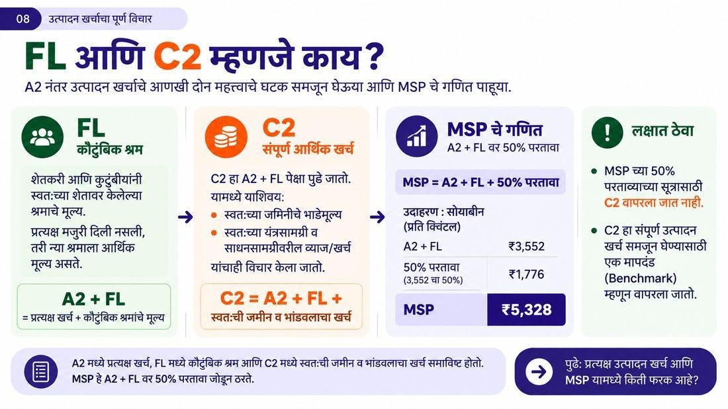
Figure 1.4 — What FL and C2 are, and the calculation of MSP
However, there is an important problem here — the published CACP price policy table does not disclose the separate rupee value of each component within the A2 figure of ₹3,552 for soybean. Because of this lack of transparency, neither farmers nor anyone else can check whether the A2 figure is a true reflection of the actual cost of producing the crop today.
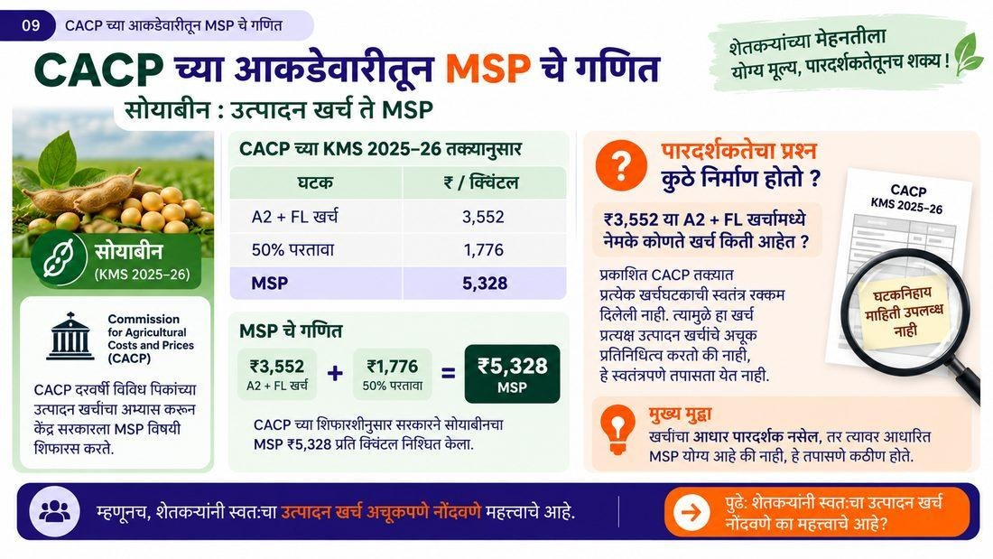
Figure 1.5 — Calculation of MSP from soybean’s actual figures (KMS 2025-26)
This is the core of this entire issue: the A2 cost that farmers actually have to bear on the ground can be much higher than the figures worked out by the government. And since MSP is based directly on A2+FL, an understated A2 means an understated MSP — however correctly the 1.5× formula is applied.
That is why, if a farmer wants to tell the government “our actual A2+FL is higher than the figure you have assumed,” the government will naturally ask for proof — and that proof is nothing other than your own farm production cost, recorded meticulously for every crop and every season.

Key Concepts
- MSP (Minimum Support Price): the minimum guaranteed price the government announces for certain crops.
- A2: the cost incurred by the farmer in cash and in kind.
- FL: the estimated economic value of the family’s labour.
- C2: the full cost worked out by adding the cost of own land and capital to A2+FL (benchmark only).
- CACP: Commission for Agricultural Costs and Prices — the body that recommends MSP to the government.

Key Takeaways
- MSP is fixed at one and a half times the production cost of farming (A2+FL) — so the more accurate the production cost figure, the fairer the MSP.
- The A2+FL figure comes from a government sample survey, which may be lower than the actual situation.
- C2 is not used in the MSP formula — it is used only for checking (benchmark).
- Recording your own production cost is the most effective tool in a farmer’s hands for demanding a fair price.

Review Questions
- What is MSP and by what formula is it fixed?
- Briefly explain the difference between A2, FL and C2.
- Why is it important to record the actual production cost of your own farming?

Module Summary
In this module we saw that MSP is the minimum support price fixed by the government, worked out at one and a half times the production cost A2+FL. A2 is the actual cash/in-kind cost incurred, FL is the value of family labour, while C2, the full cost, is used only as a benchmark. If the production cost figure in the government survey is lower than the actual situation, the MSP also remains low — and the only way to change this is for farmers to record their own production cost regularly and accurately.

